Various Shapes and their codes. By – Ayush Gattani  
  
1**. Normal Triangle**

import turtle

t = turtle.Turtle()

t.forward(120)

t.left(120)

t.forward(120)

t.left(120)

t.forward(120)

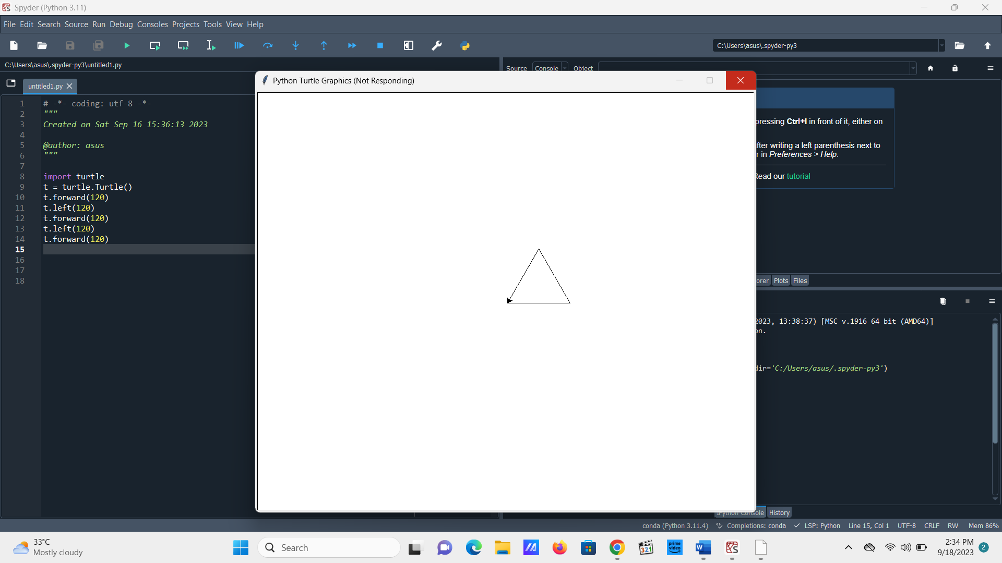

1. **Right Angled Triangle**

import turtle

t = turtle.Turtle()

t.forward(200)

t.left(120)

t.forward(390)

t.left(150)  
t.forward(340)

1. **House**

t.forward(120)

t.left(120)

t.forward(120)

t.left(120)

t.forward(120)

t.left(30)

t.forward(120)

t.left(90)

t.forward(120)

t.left(90)

t.forward(120)

t.left(180)

t.forward(120)

t.left(90)

t.forward(200)

t.left(90)

t.forward(120)

t.left(90)

t.forward(200)

t.right(60)

t.forward(120)

t.right(120)

t.forward(200)

t.right(60)

t.forward(120)

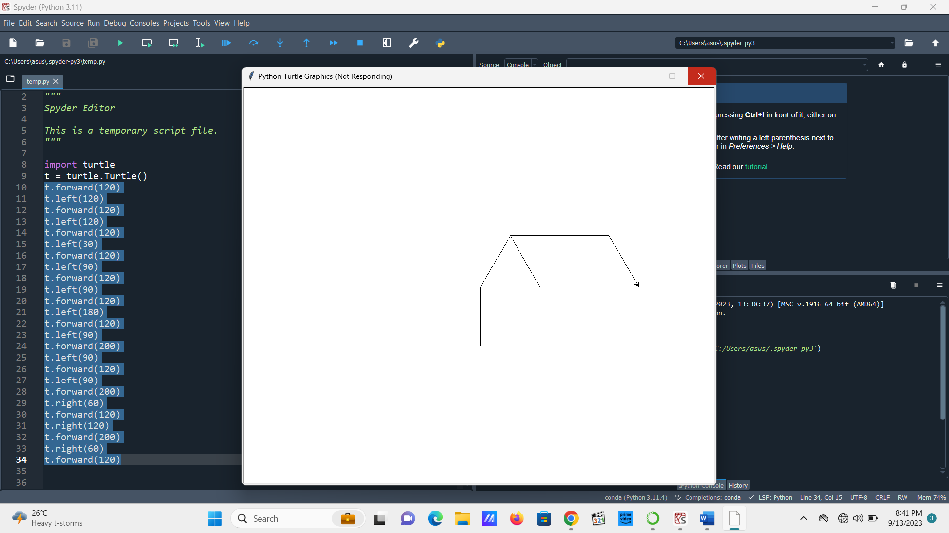  
  
**4. Archway**

t = turtle.Turtle()

t.forward(150)

t.left(90)

t.forward(150)

t.left(90)

t.forward(150)

t.left(90)

t.forward(150)

t.left(90)

t.forward(25)

t.left(90)

t.forward(120)

t.right(90)

t.forward(100)

t.right(90)

t.forward(120)

t.right(90)

t.forward(25)

t.right(90)

t.forward(90)

t.left(90)

t.forward(50)

t.left(90)

t.forward(90)  
  
  
  
  
  
  
  
  
**5. House with door and window**  
  
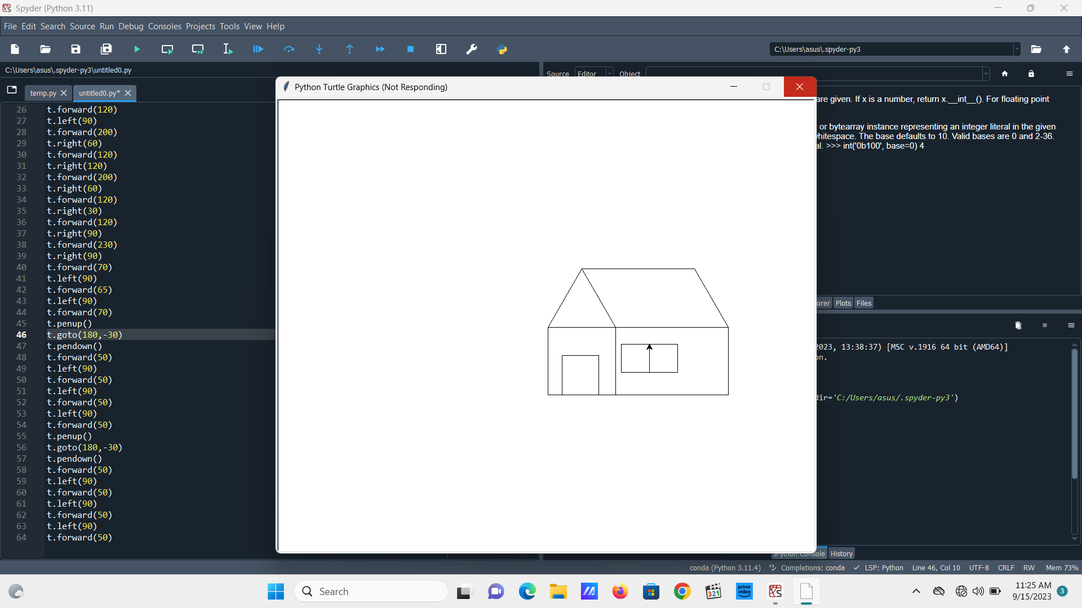  
  
import turtle

t = turtle.Turtle()

t.forward(120)

t.left(120)

t.forward(120)

t.left(120)

t.forward(120)

t.left(30)

t.forward(120)

t.left(90)

t.forward(120)

t.left(90)

t.forward(120)

t.left(180)

t.forward(120)

t.left(90)

t.forward(200)

t.left(90)

t.forward(120)

t.left(90)

t.forward(200)

t.right(60)

t.forward(120)

t.right(120)

t.forward(200)

t.right(60)

t.forward(120)

t.right(30)

t.forward(120)

t.right(90)

t.forward(230)

t.right(90)

t.forward(70)

t.left(90)

t.forward(65)

t.left(90)

t.forward(70)

t.penup()

t.goto(180,-30)

t.pendown()

t.forward(50)

t.left(90)

t.forward(50)

t.left(90)

t.forward(50)

t.left(90)

t.forward(50)

t.penup()

t.goto(180,-30)

t.pendown()

t.forward(50)

t.left(90)

t.forward(50)

t.left(90)

t.forward(50)

t.left(90)

t.forward(50)

**6. Octagon**

t.left(90)

t.forward(100)

t.left(60)

t.forward(110)

t.left(60)

t.forward(100)

t.left(60)

t.forward(105)

t.left(60)

t.forward(100)

t.left(57)

t.forward(109)

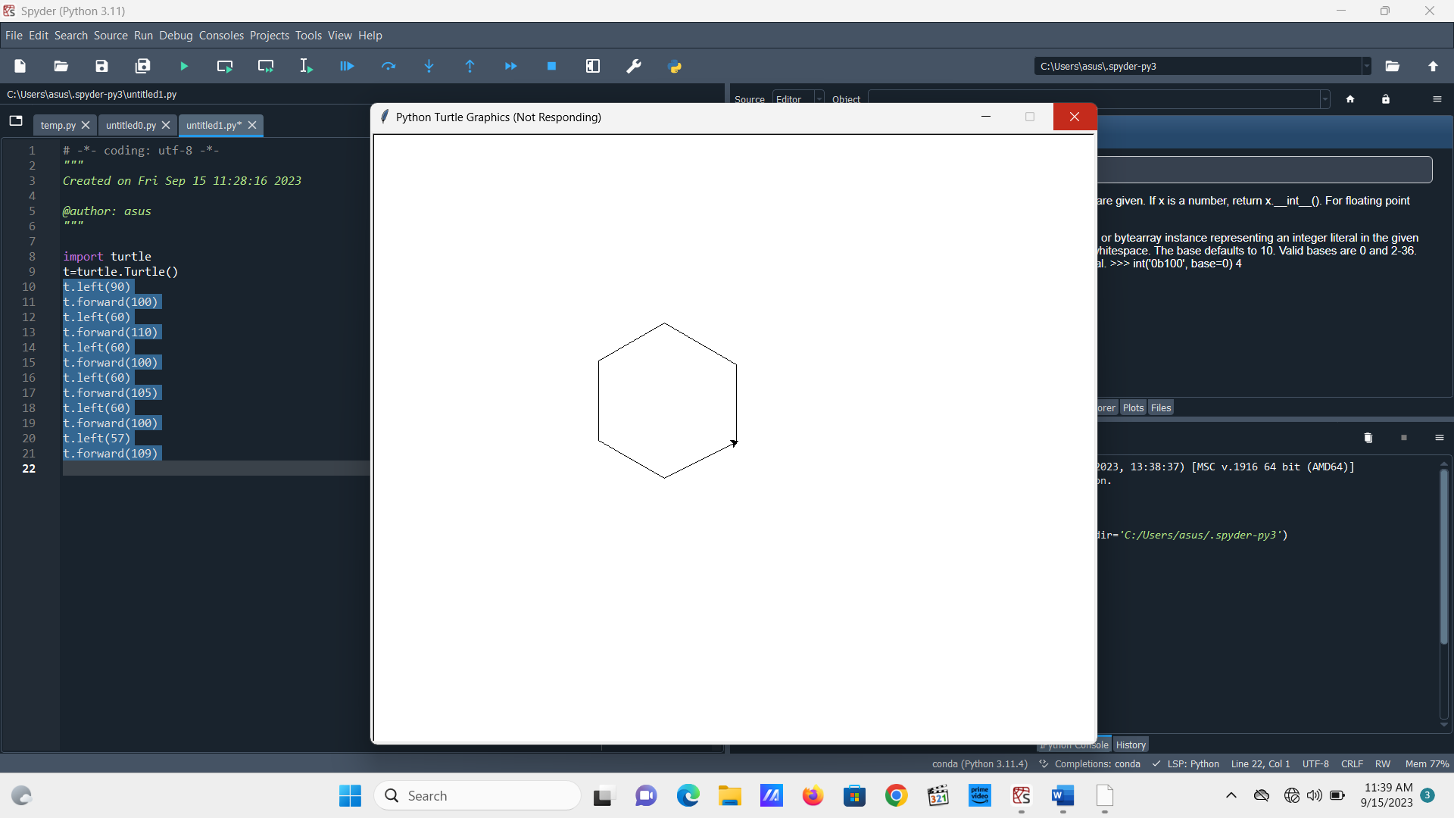

**7. Isoceles Triangle**

t.right(90)

t.forward(150)

t.left(120)

t.forward(150)

t.left(120)

t.forward(160)

**8. Star**

t.right(75)

t.forward(100)

t.right(180)

t.forward(100)

t.left(140)

t.forward(100)

t.left(140)

t.forward(100)

t.left(150)

t.forward(110)

t.left(151)

t.forward(110)  
  
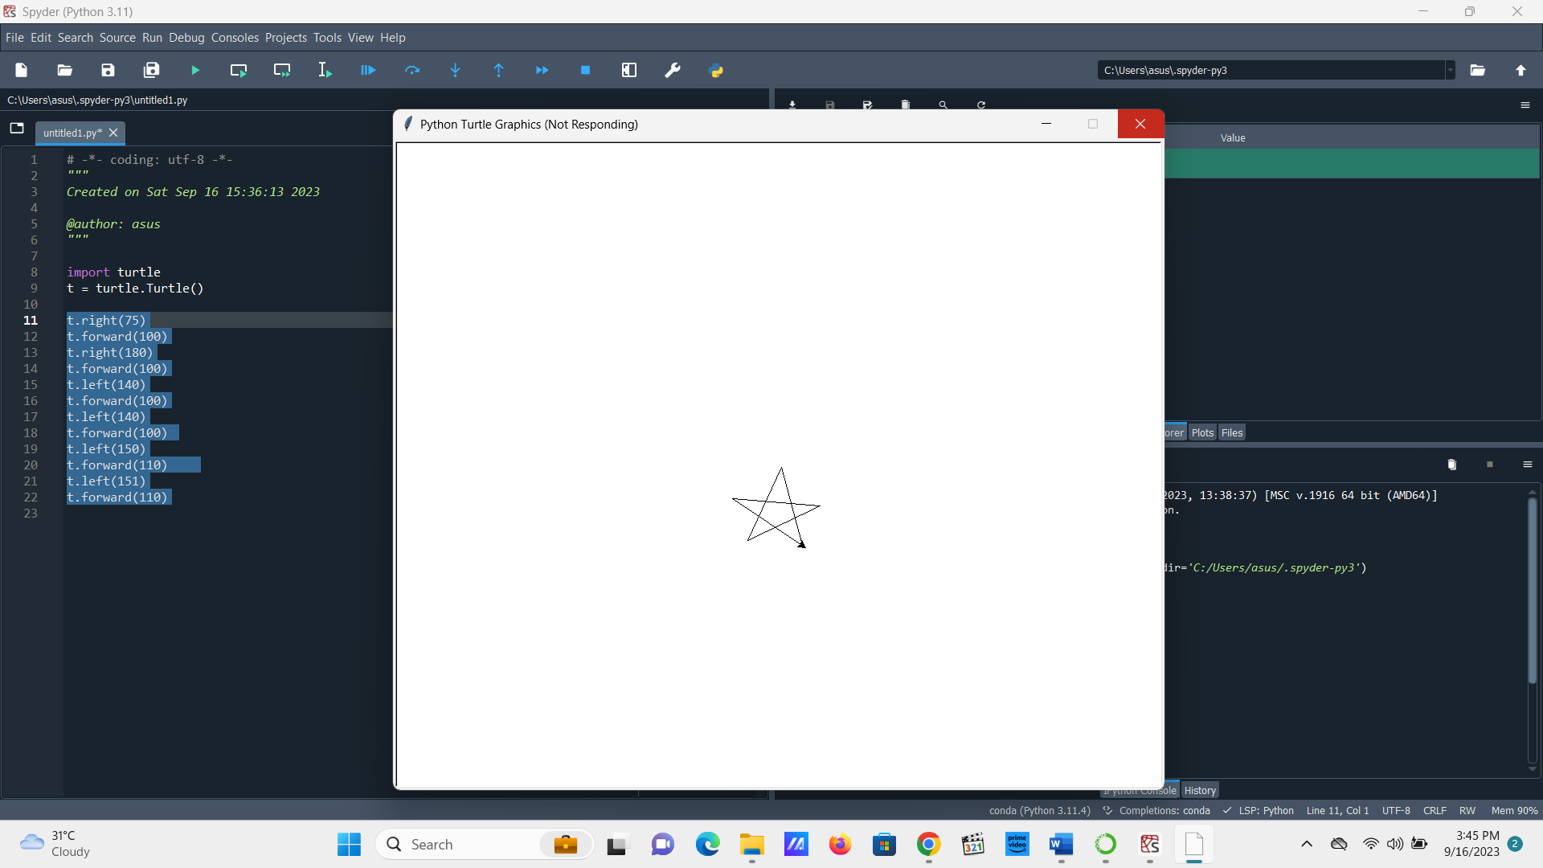

**9. Hexagon**

t.forward(100)

t.right(60)

t.forward(100)

t.right(60)

t.forward(100)

t.right(60)

t.forward(100)

t.right(60)

t.forward(100)

t.right(60)

t.forward(100)  
  
**10. Scalene Triangle**

t.left(60)

t.forward(150)

t.right(120)

t.forward(200)

t.right(134)

t.forward(182)   
  
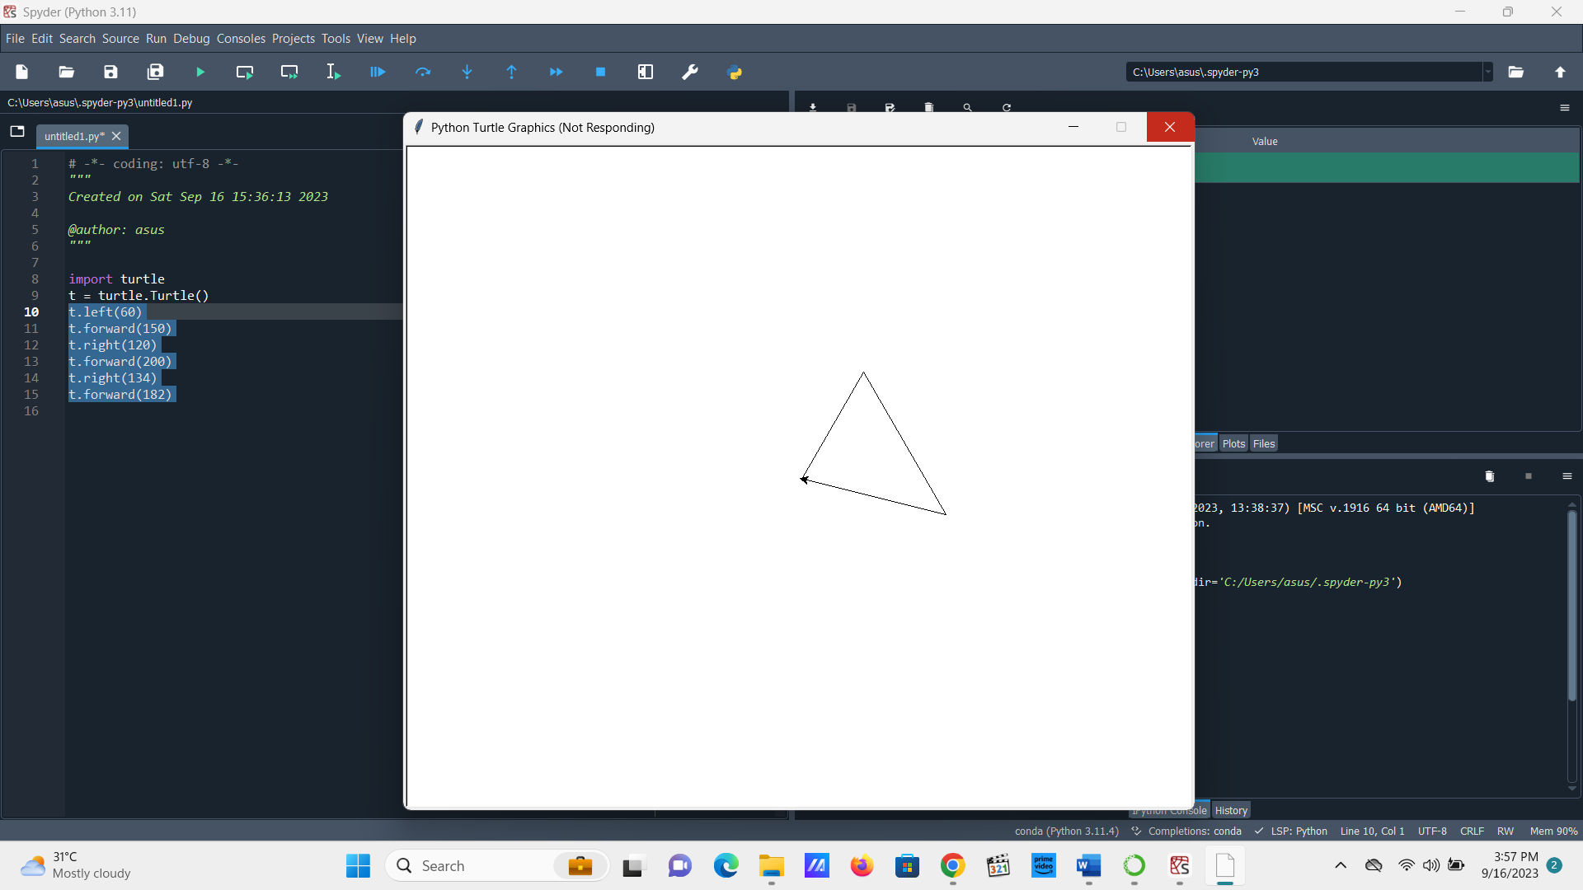

**11. Pentagon**

t.left(60)

t.forward(150)

t.right(120)

t.forward(150)

t.right(30)

t.forward(130)

t.right(90)

t.forward(150)

t.right(90)  
t.forward(130)

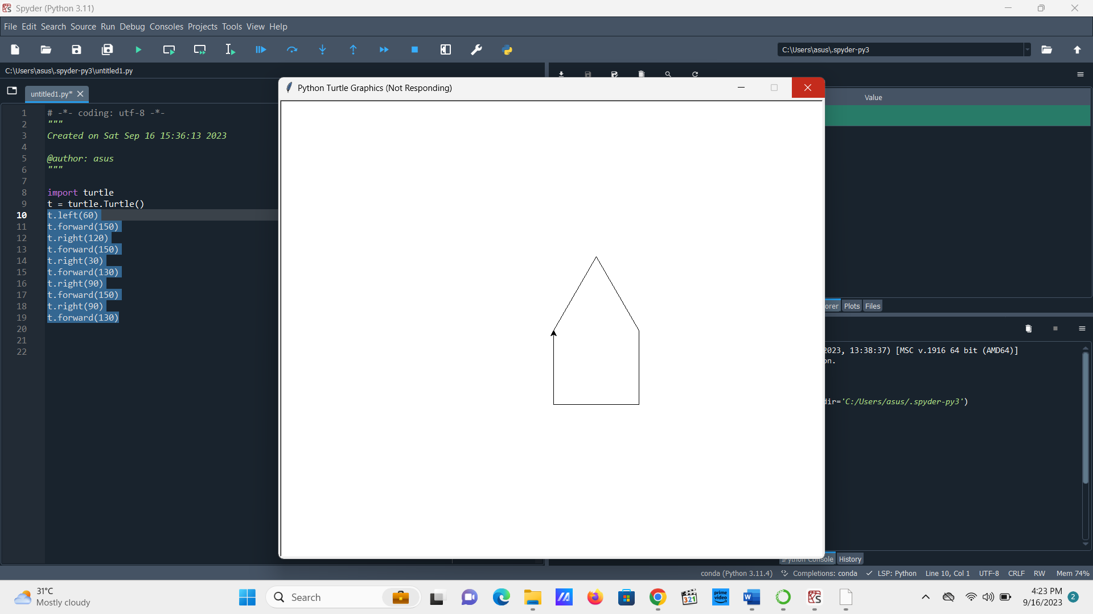  
  
  
  
**12. Heptagon**

t.left(30)

t.forward(120)

t.right(60)

t.forward(120)

t.right(50)

t.forward(120)

t.right(55)

t.forward(120)

t.right(50)

t.forward(120)

t.right(60)

t.forward(120)

t.right(43)  
t.forward(95)

**13. Triangle in a circle**

t.circle(100,180)

t.circle(100,180)

t.left(45)

t.forward(144)

t.left(116)

t.forward(188)

t.left(134)

t.forward(185)  
  
**14. Face**

t.forward(250)

t.left(120)

t.forward(250)

t.left(120)

t.forward(250)

t.circle(145,240)

t.penup()

t.goto(70,-55)

t.pendown()

t.left(60)

t.circle(20)

t.penup()

t.goto(175,-55)

t.pendown()

t.circle(20)

t.penup()

t.goto(125,-100)

t.pendown()

t.circle(10,240)

t.penup()

t.goto(130,-160)

t.pendown()

t.circle(10)

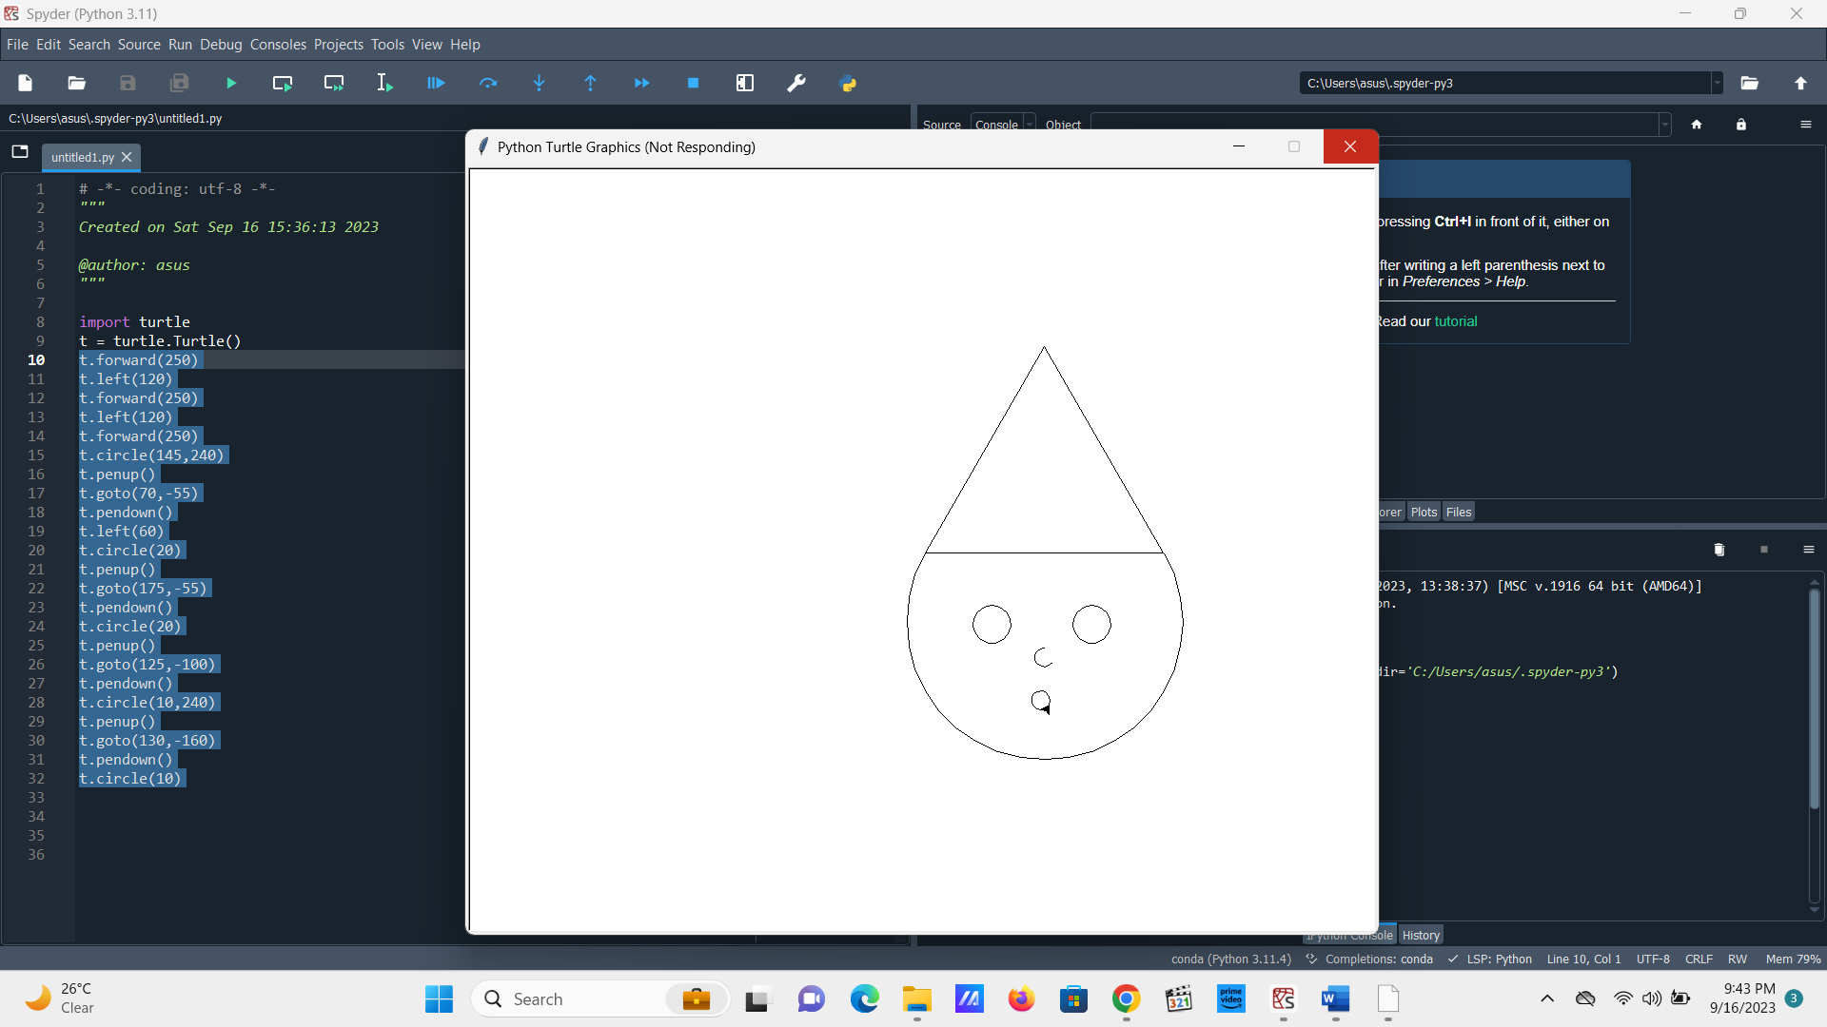

**15. Square loop**

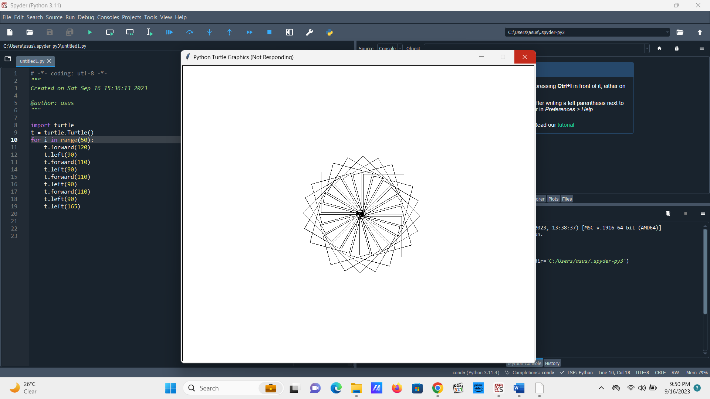

for i in range(50):

t.forward(120)

t.left(90)

t.forward(110)

t.left(90)

t.forward(110)

t.left(90)

t.forward(110)

t.left(90)

t.left(165)

**16. Triangle Loop**for i in range(50):

t.forward(195)

t.left(120)

t.forward(200)

t.left(122)

t.forward(200)

t.left(60)

